Department of Electrical Engineering
The Superior University, Lahore

Computer Programming

Experiment No.3
The Use of Input/Output Operations (Beginner to Advanced Level)

Prepared for:
Eisha Nawaz
By:
Name: Tanseer Haider
ID: SU91-BSEEM-F25-02
Section: Electrical Engineering Fall 25
Semester: 2nd

Total Marks: _______10________
Obtained Marks: ______________
Signature: __________________
Date: _______________

Experiment No.3
The Use of Input/Output Operations (Beginner to Advanced Level)
(Rubrics)

Name: Tanseer Haider ID: SU91-BSEEM-F25-02

- PSYCHOMOTOR
Serial No. | Criteria | Allocated Marks | Unacceptable  0% | Poor  25% | Fair  50% | Good  75% | Excellent  100% | Total Obtained
1 | Follow Procedures | 2 | 0 | 0.5 | 1 | 1.5 | 2
2 | Accuracy in Output Results | 4 | 0 | 1 | 2 | 3 | 4
Sub-Total |  | 6 | Sub Total Marks Obtained in Psychomotor (P)

- AFFECTIVE
Serial No. | Criteria | Allocated Marks | Unacceptable  0% | Poor  25% | Fair  50% | Good  75% | Excellent  100% | Total Obtained
1 | Lab Report | 2 | 0 | 0.5 | 1 | 1.5 | 2
2 | Assigned Task | 2 | 0 | 0.5 | 1 | 1.5 | 2
Sub-Total |  | 4 | Sub Total Marks Obtained in Affective (A)

Instructor Name: | _Miss Eisha Nawaz_ | Total Marks (P+A): | ______10_____
Instructor Signature: | ______________ | Obtained Marks (P+A): | ______________

Contents Of Lab 3
1 Lab Objective(s) 4
2 Introduction to Print Statement 4
2.1 COUT in C++ 4
2.1.1 Syntax 4
2.1.2 Example 1 4
2.2 Use of STD 5
2.2.1 Example 2 (using Namespace std) 5
3 Escape Sequences 5
3.1.1 New Line (\n): 5
3.1.2 Tab (\t): 5
3.1.3 Alert Bell (\a): 6
3.1.4 Backspace (\b): 6
3.1.5 Single Quote (\’): 6
3.1.6 Carriage Return (\r): 6
3.1.7 Form Feed (\f) 6
3.1.8 Example 3 7
4 Lab Tasks 8
4.1 Task 1 8
4.2 Task 2 8
4.3 Task 3 9
4.4 Task 4 9
5 Home Assignment 9
5.1 Task 1 9
5.2 Task 2 10
5.3 Task 3 10

The Use of Input/ Output Operations (Beginner to Advanced Level)
- Lab Objective(s)
- To understand the use of print statements from beginner to advance level
- To learn print statements based on complex problems and spacing mechanism

Introduction to Variables

Variable Declaration in C++
A variable declaration provides assurance to the compiler that there is one variable existing with the given type and name so that compiler proceed for further compilation.
int a;
char b;
float c;

Variable Initialization in C++
A variable can be initialized at the time of declaration or even after that. Basically, initialization means storing some actual meaningful data inside the variable.
int a=2;
char b=’x’;
float c=2.907;

Constants
Constants refer to fixed values that the program may not alter during its execution. These fixed values are
also called literals.

Defining Constants
There are two simple ways in C++ to define constants:
Using #define preprocessor
Using const keyword
#define LENGTH 10
#define WIDTH 5
const int LENGTH = 10;
const int WIDTH = 5;

Legal Identifiers
Regardless of which style you adopt, be consistent and make your variable names as sensible as possible. Here are some specific rules that must be followed with all identifiers.
- The first character must be one of the letters a through z, A through Z, or an underscore
character (_).
- After the first character you may use the letters a through z or A through Z, the digits 0 through
9, or underscores.
- Uppercase and lowercase characters are distinct. This means Items Ordered is not the same as
Items ordered.
- Introduction to Print Statement
Every programming language employs a statement to print desired output on the screen. Since we are using C++, it employs COUT function to print output on screen or console.
  - COUT in C++
- COUT function are inbuilt library functions in C++ programming language which are available in C++ library by default. These functions are declared and related macros are defined in “using namespace std” which is a header file in C++ language.
- We have to include “using namespace std” file as shown in below C++ program to make use of COUT library function in C++ language.
    - Syntax
The syntax of COUT function is displayed below:
COUT<<“”;
The description is as follows:
- COUT is pre-defined statement which is necessary to be written in order to print something
- The "c" in cout refers to "character" and "out" means "output".
- Hence cout means "character output".
- The cout object is used along with the insertion operator << in order to display a stream of characters.
    - Example 1
#include<iostream>
int main ()
{
std::cout<< “Hello World”;
return 0;
}
Output
Hello World
  - Use of STD
- In the previous example, we saw that before COUT we used “std::”.
- C++ moved all of the functionality in the standard library into a namespace named “std” (short for standard)
- Hence, is we use “using namespace std” before our main() function, we wont have to write std:: before the cout statement
    - Example 2 (using Namespace std)
#include<iostream>
using namespace std;
int main()
{
cout<< “Hello World”;
return 0;
}
Output
Hello World
- Escape Sequences
Escape sequences are special characters used in control string to modify the format of an output. These specific characters are translated into another character or a sequence of characters that may be difficult to represent directly. For example, you want to put a line break in the output of a C++ statement then you will use “\n” character which is an escape sequence itself.
An escape sequence consists of two or more characters. For all sequences, the first character will be ”\” i.e. backslash. The other characters determine the interpretation of escape sequence. For example, “n” of “\n” tells the cursor to move on the next line.
    - New Line (\n):
When a new line is necessary in the output, then this escape sequence is used. For example:
cout<<”COMPUTER\nSCIENCE”;
First of all, “COMPUTER” is printed and”\n” shifts the cursor to the next line. Then “SCIENCE” is printed on second line. A screenshot of output is shown below:
    - Tab (\t):
- A TAB is equal to eight spaces. Whenever TAB button is pressed from the keyboard, then 8 spaces are left blank. This escape sequence performs the functionality of TAB key in the output stream.
- The code given below will insert a TAB between two words.
cout<<”COMPUTER\tSCIENCE”;
C++ Tab (\t)
- As you can see after printing “COMPUTER”, 8 spaces are left blank and then “SCIENCE” is printed on the screen
    - Alert Bell (\a):
- This escape sequence is used to play beep during execution. For example:
cout<<”COMPUTER\aSCIENCE”;
- First of all, “COMPUTER” is printed then a beep is played and after that “SCIENCE” is printed.

    - Backspace (\b):
- Whenever we want to delete a single character, we press the button “backspace” from our keyboard. The same functionality can be achieved in C++ output with this escape sequence. For example:
cout<<”COMPUTER\bSCIENCE”;
C++ Backspace (\b)
- First of all, “COMPUTER” is printed and after that “\b” comes which deletes the last character i.e. “R”. After that, “SCIENCE” is printed.

    - Single Quote (\’):
- To insert a single quote in the output, this escape sequence is used. Look at the code written below:
cout<<”\’COMPUTER SCIENCE\’”;
- This code prints single quotes at the start and end of the string.

    - Carriage Return (\r):
- This escape sequence moves the cursor at the beginning of current line. For example:
cout<<”COMPUTER\rSCIENCE”;
- First of all, “COMPUTER” is printed and after that “\r” comes which moves the cursor at the beginning of the line and “SCIENCE” is printed which overwrites the word written before.

    - Form Feed (\f)
- This escape sequence is used in printing. It is used to insert a blank paper in the printed output. For example:
cout<<”COMPUTER\fSCIENCE”;
- After printing “COMPUTER”, the computer will include a blank paper and then print “SCIENCE”.

    - Example 3
#include<iostream>
using namespace std;
int main()
{
cout<< “########\n”;
cout<<”#\t#\n”;
cout<<”#\t#\n”;
cout<< “########\n”;
return 0;
}
Output
########
# #
# #
########

- Lab Tasks

Task 1
Write a C++ program to print a SUPERIOR using hash (#).

Expected Output:
###### # # ######### ######### ######## ########## ##### ######
# # # # # # # # # # # # #
# # # # # # # # # # # # #
###### # # ######### ###### ######## # # # ######
# # # # # # # # # # # #
# # # # # # # # # # # #
###### ######### # ######### # # ######### ##### # #

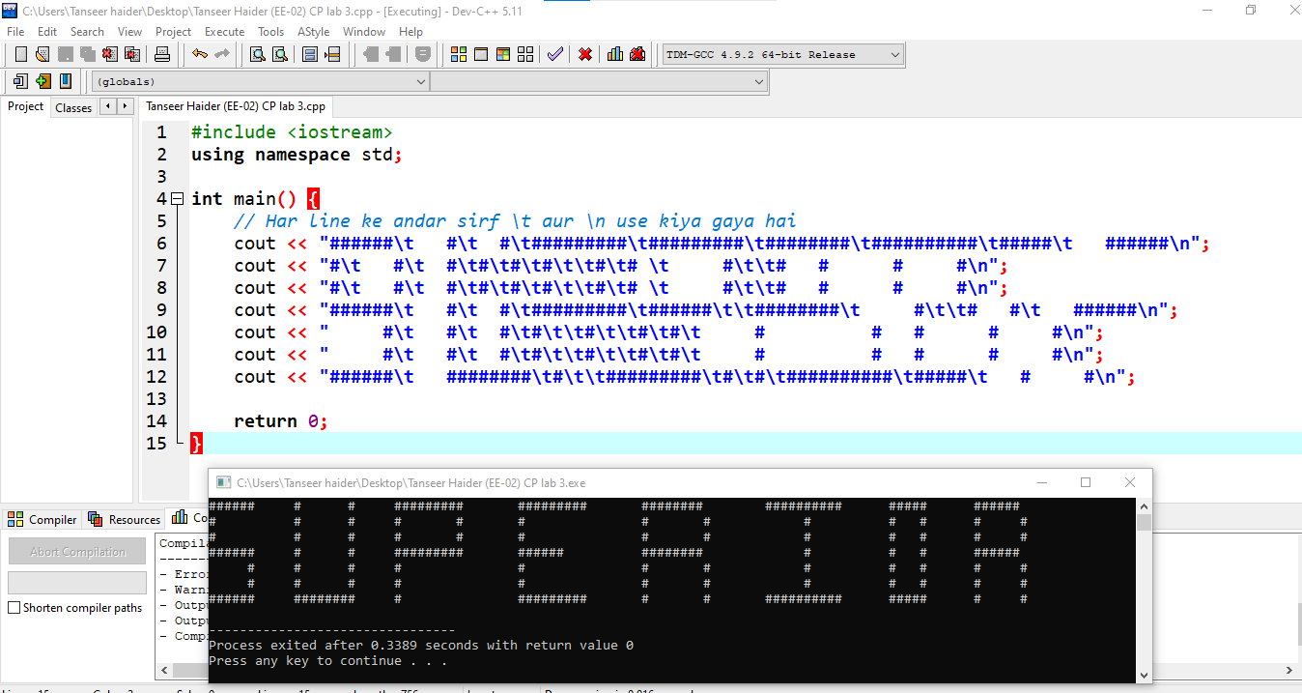

Task 2
Write a C++ program to print the following:

Expected Output
**************
# 10 $
$ 789 #
# 456 $
$ 123 #
**************

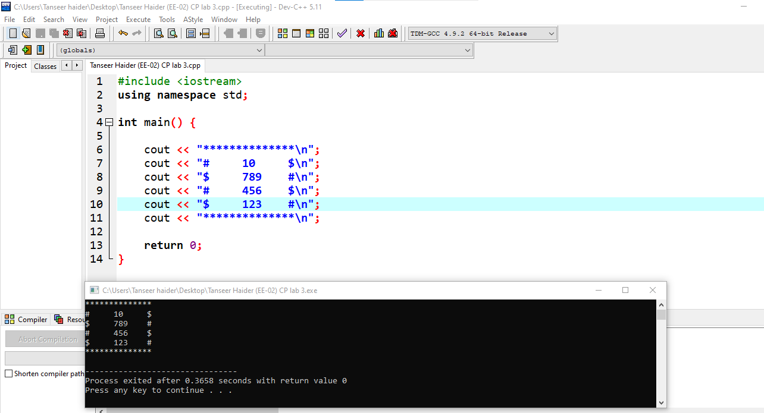

Task 3
Write a C++ program to print the following:
Expected Output
######################
# My Name is ABC #
#######################
#| Inter Marks | 900 | #
#| Matric Marks | 900 | #
#######################
#| Total Marks | 1800 |#
#######################
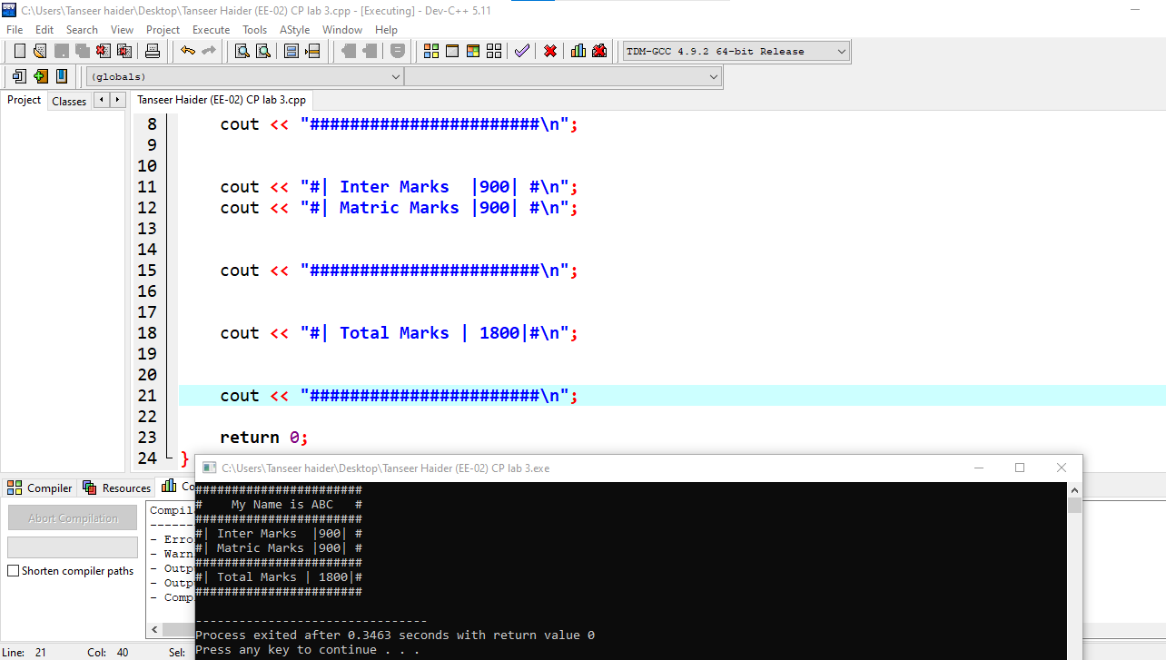

Task 4
Write a C++ program to print the following:

Expected Output
***Inventory Management System***
Number of Item | Name of Item | Quantity | Price | Stock Requirement
1 | Transistor | 56 | $40 | 13
2 | Diode | 45 | $12 | 16
3 | Breadboard | 43 | $17 | 32
4 | Wires | 100 | $23 | 23
5 | Multimeter | 15 | $34 | 5

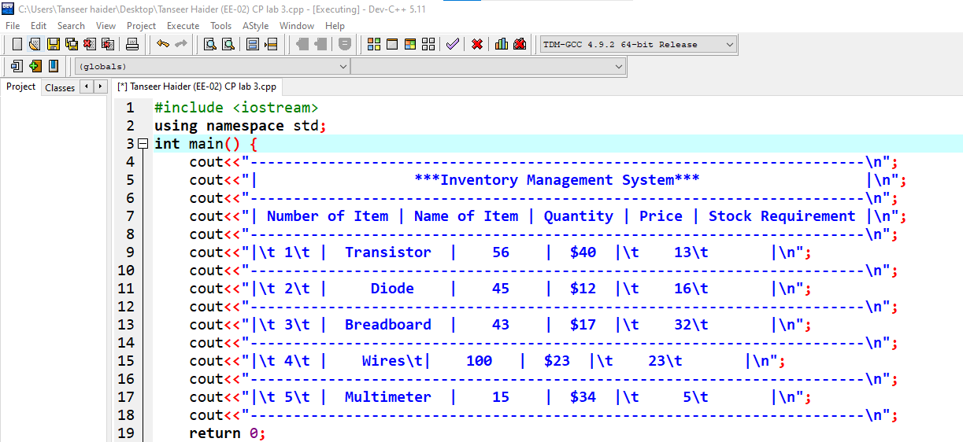

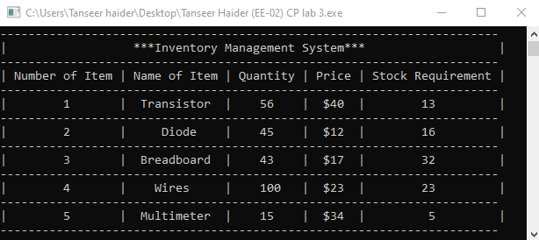

- Home Assignment

Task 1
Total Purchase A customer in a store is purchasing five items. The prices of the five items are:
Price of item 1 = $12.95
Price of item 2 = $24.95
Price of item 3 = $6.95
Price of item 4 = $14.95
Price of item 5 = $3.95
Write a program that holds the prices of the five items in five variables. Display each items price, the subtotal of the sale, the amount of sales tax, and the total. Assume the sales tax is 6%.
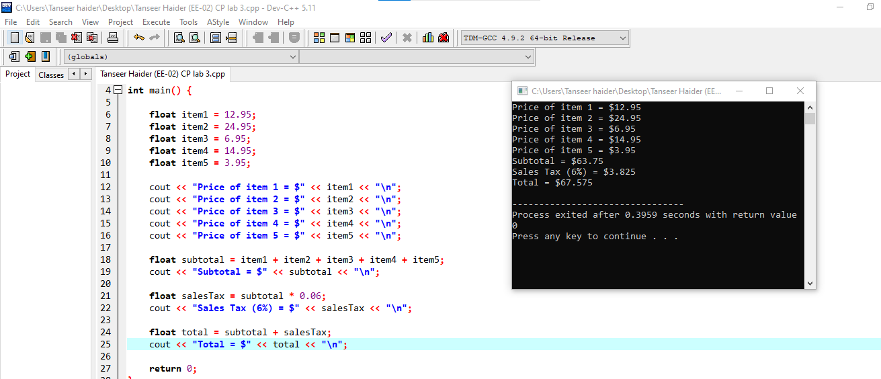

Task 2
Write a C++ program to print the following:

Expected Output
****Table of 2****
__________________
| 2 | x | 1 | = | 2 |
| 2 | x | 2 | = | 4 |
| 2 | x | 3 | = | 6 |
| 2 | x | 4 | = | 8 |
| 2 | x | 5 | = | 10 |
| 2 | x | 6 | = | 12 |
___________________

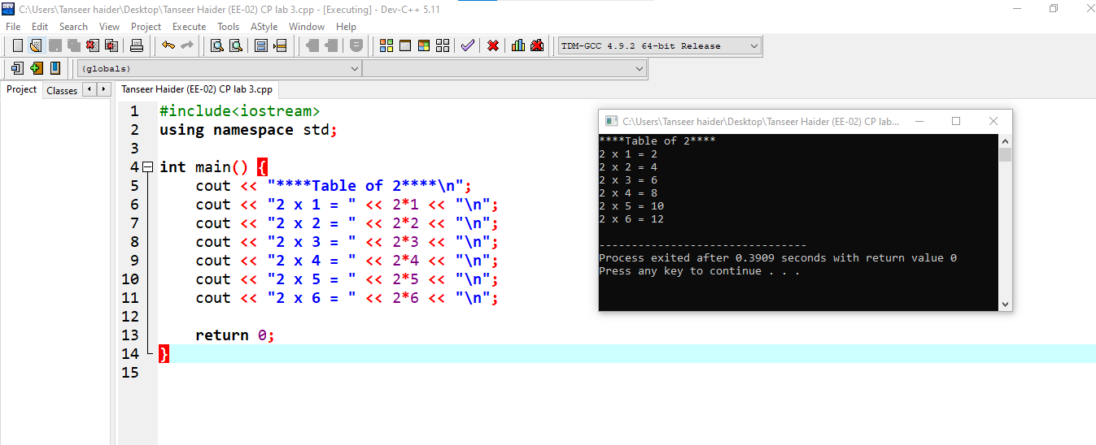

Task 2
Write a C++ program to print the following:

Expected Output
__________________________________________
**Table of 2** |*| ** Table of 3**
__________________________________________
** |2|x|1| = |2| |*| |3|x|1| = |2| **
** |2|x|2| = |4| |*| |3|x|2| = |6| **
** |2|x|3| = |6| |*| |3|x|3| = |9| **
** |2|x|4| = |8| |*| |3|x|4| = |12| **
__________________________________________
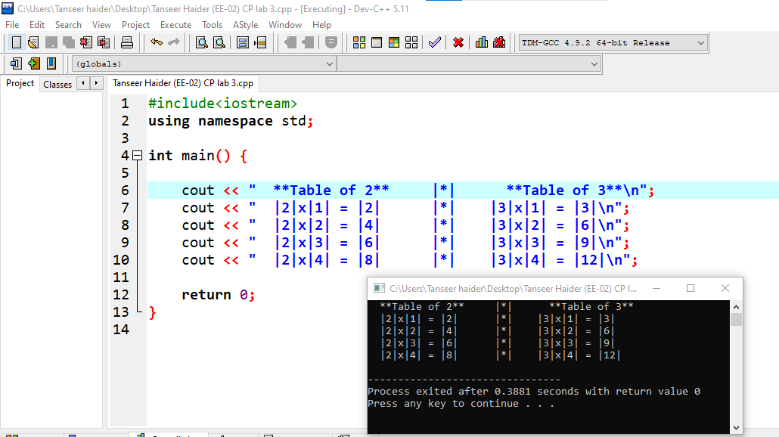

Task 3
Write a C++ program to print the following:

Expected Output
--------------------------------------
| 2+3 |
| =5 |
--------------------------------------
| [7] [8] [9] || [+] [-] |
| [4] [5] [6] || [x] [/] |
| [1] [2] [3] || [Compute] |
| [A] [0] [B] || [ Clear] |
--------------------------------------
In the displayed figure, 2,3, and 5 are integer values which are inserted by the user.
